16.ONLINE INTERNSHIP REGISTRATION SYSTEM

COMPONENT DIAGRAM

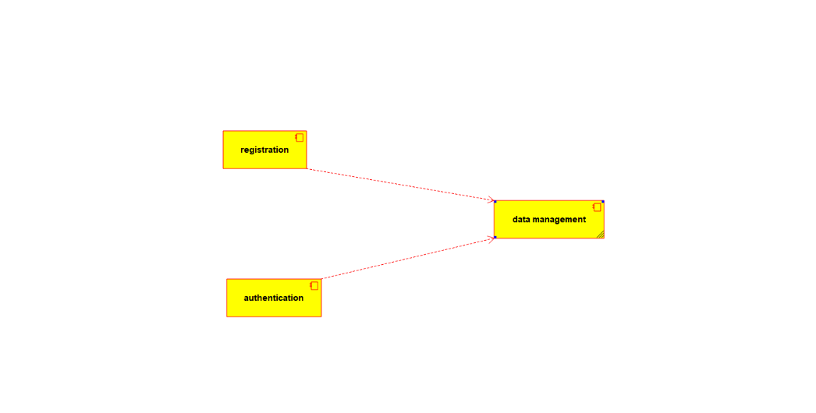

STATE CHART DIAGRAM

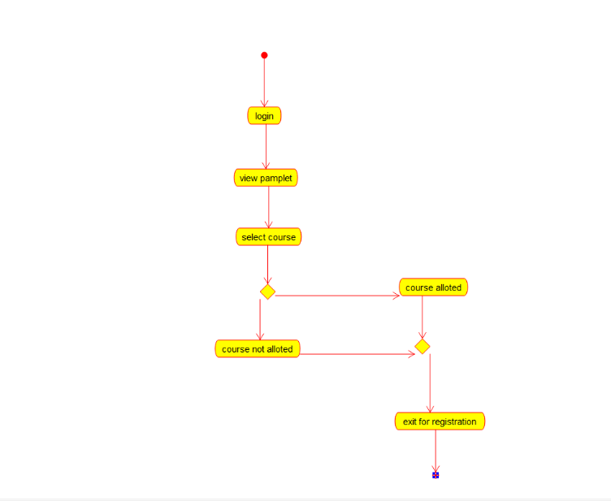

USECASE DIAGRAM

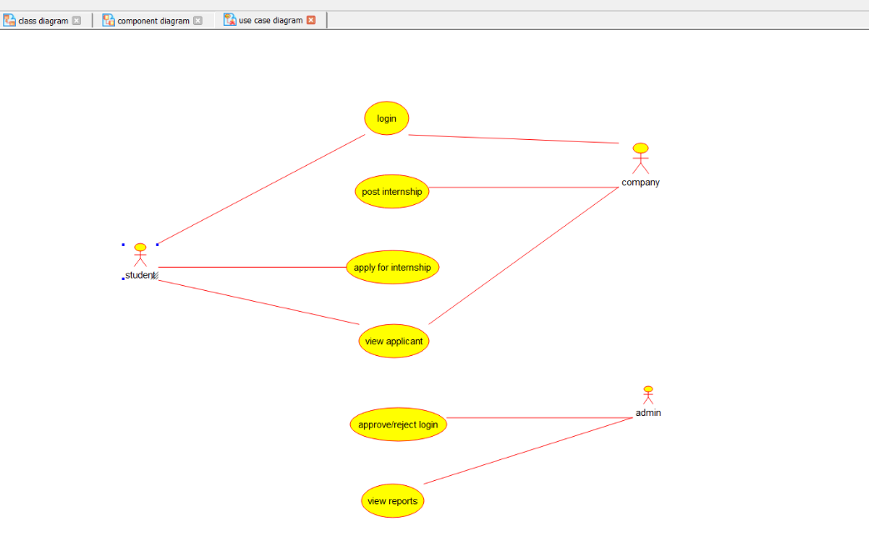

CLASS DIAGRAM

